**User Manual**

Project Name: Digital University

Module Name: Asset Management  
(Project, Thesis, Email, Asset)

Founder, Framework and Architecture:

**Dr. KAZI MASUDUL ALAM**

**Associate Professor**

**CSE Discipline**

**Khulna University**

Developed by:

Sheikh Sohel Moon (160202)

Mesbah Ur Rahman (160218)

Ferdousi Haque (160228)

**FIRST LOOK**

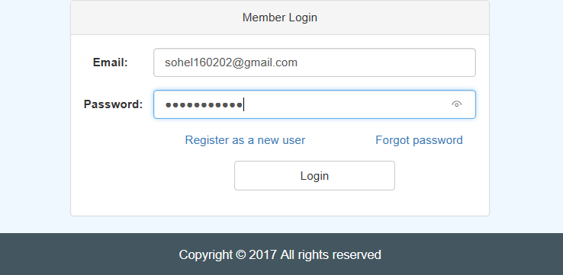

Login Form

1. In the main page The user will have the login form to have login and also there will be links to request as a new user and forgot password.
2. There are 6 kinds of Users functionality (which can be increased) based on the role of the user in his university and the permissions his role permits.

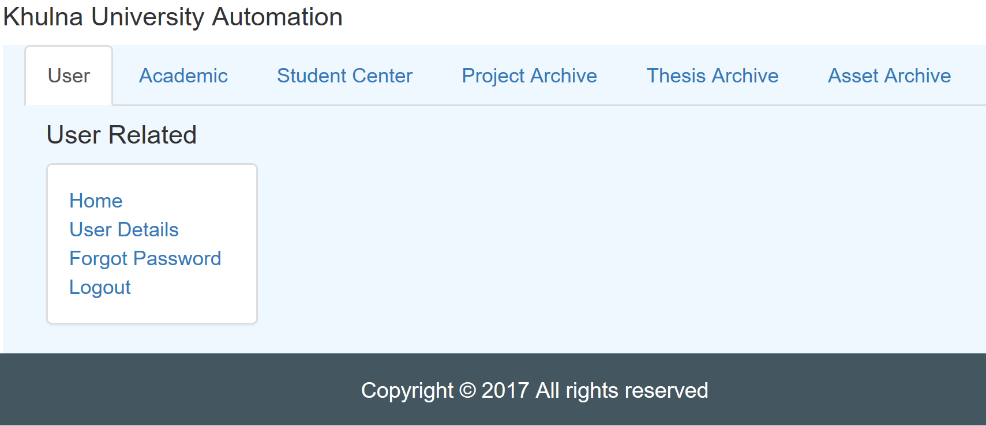

After Student Login

1. As the students have so many restrictions while in the next photo we can see the admin can see each and every thing of the website which ensure a secure and disciplined way to maintain the website.

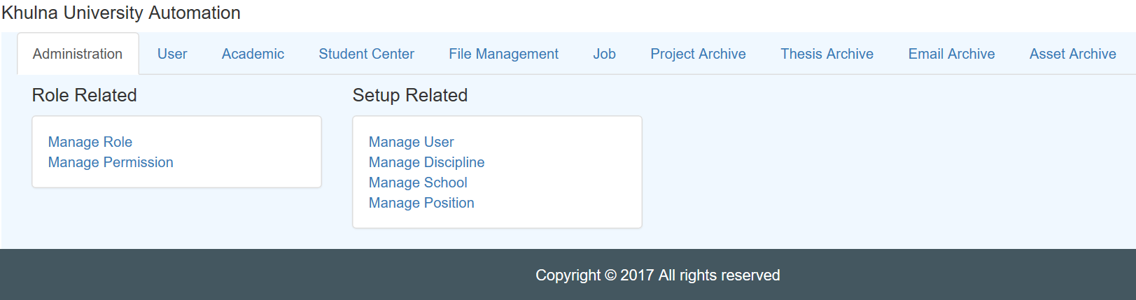

After Admin Login

1. After login one user can go to his desired module in two ways. Either from the Top Bar menu or from the middleware menu box.

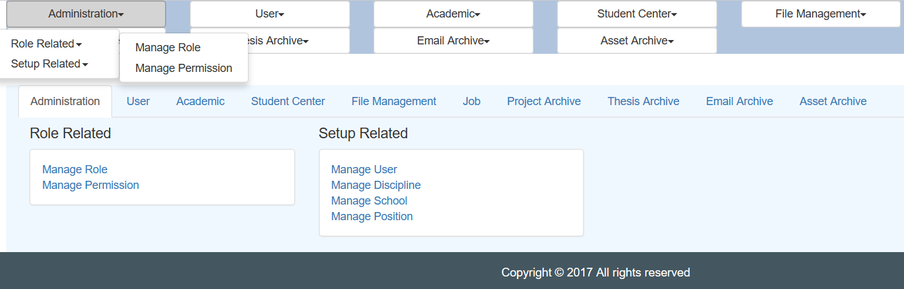

**PROJECT ARCHIVE**

Project Archive will work as a store with the full information of the projects done by the students in the different times of during their Under Graduation / Graduation.   
  
There are 3 main use of this Module.  
1. Manage Projects (To Create New Project or Edit an existing one)   
2. Browse Projects (To Browse Previous All Project)  
3.Search Projects (To Search a Previous Project in basis of some information)

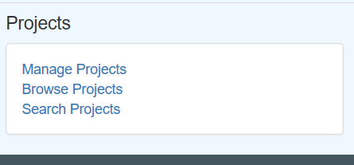

1. Manage Projects:  
     
   The Page of Manage Project has two parts. The First part is a “Create Project” Form. User can store the information of a new project by giving the Title, Language, Year, Term, Course No, Discipline, Teacher, Description and Thumbnali of that project. After giving all the information the user have to click the “Create” Button.   
     
   Another part of the page is consist of the data from the databse about the Projects which are already stored here. If the user has the permission, he can also “Edit” or “Delete” an existing Proejct.

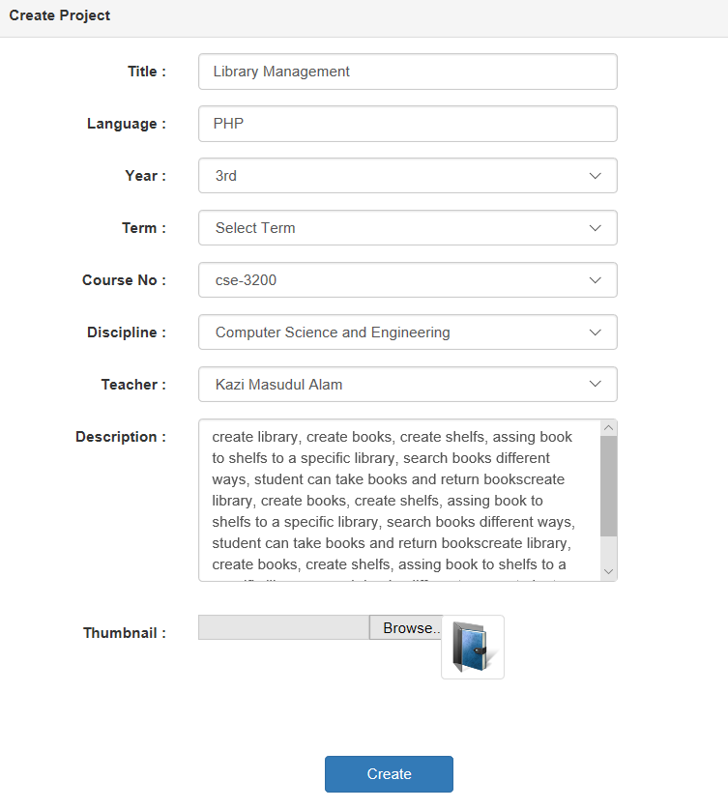

Create Project Form

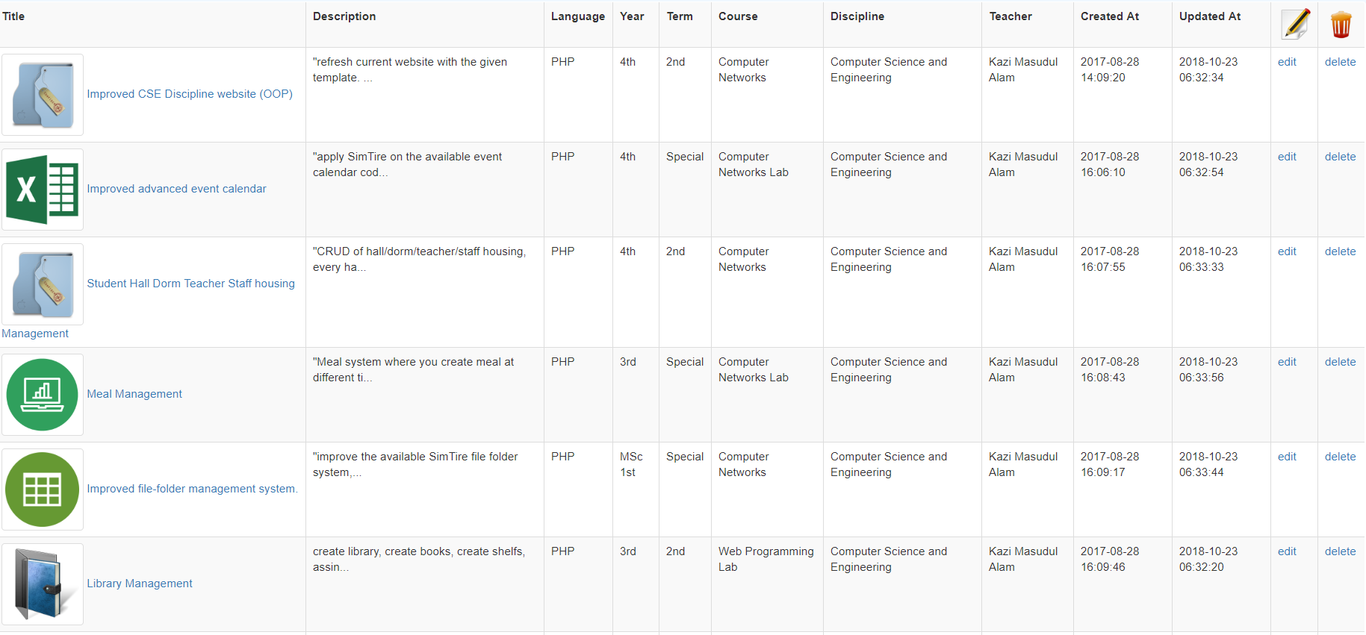

Existing Projects Showing in Manage Project

1. Browse Projects  
   This page will show the user all the previous projects which have been done by the students. First it will give a Thumbnail look with the project name and a small description. User can select from here and see the Full of the project.

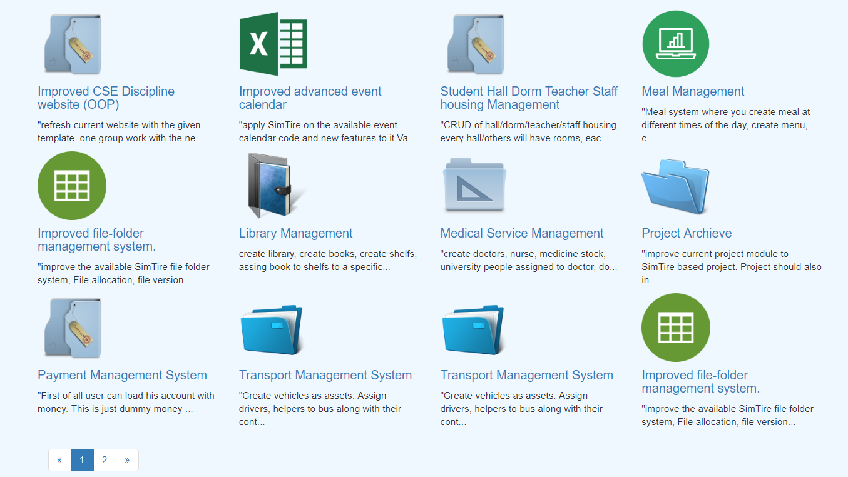

Browse Projects

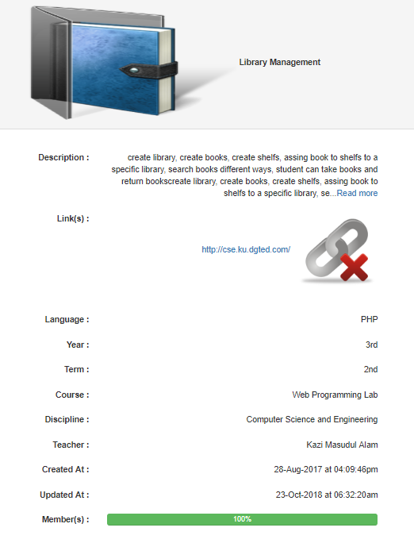

Showing one particular Project

1. Search Projects  
   This page give the user the privilege to search one or more previous project with using some particular information like Title, Year, Term, Teacher etc. which will reduce the search result from all the previous projects.

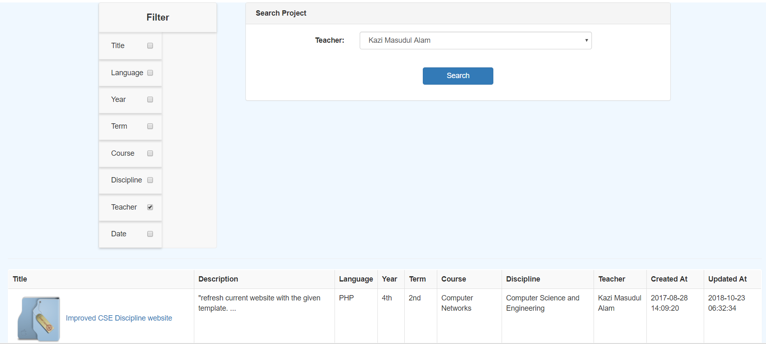

**THESIS ARCHIVE**

Thesis Archive will work as a store with the full information of all the thesis done by the students during their Under Graduation / Graduation.

There are 3 main use of this Module.  
1. Manage Thesis (To Create New Thesis or Edit an existing one)   
2. Browse Thesis (To Browse Previous All Thesis)  
3.Search Thesis (To Search a Previous Thesis in basis of some information)

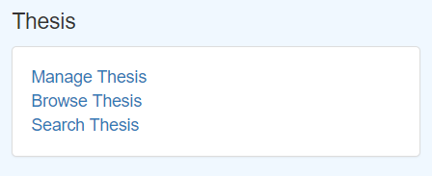

1. Manage Projects:  
     
   The Page of Manage Thesis has two parts. The First part is a “Create Thesis” Form. User can store the information of a new Thesis by giving the Title, Language, Year, Term, Course No, Discipline, Description and Thumbnali of that project. After giving all the information the user have to click the “Create” Button.   
     
   Another part of the page is consist of the data from the databse about the Thesis which are already stored here. If the user has the permission, he can also “Edit” or “Delete” an existing Proejct.

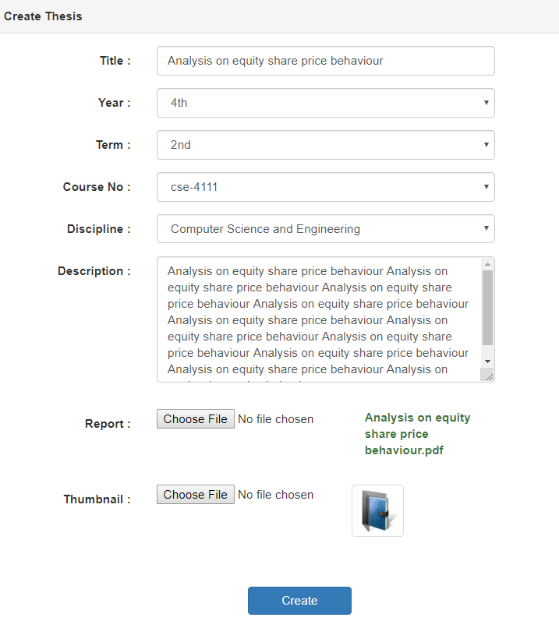

Create Thesis Form

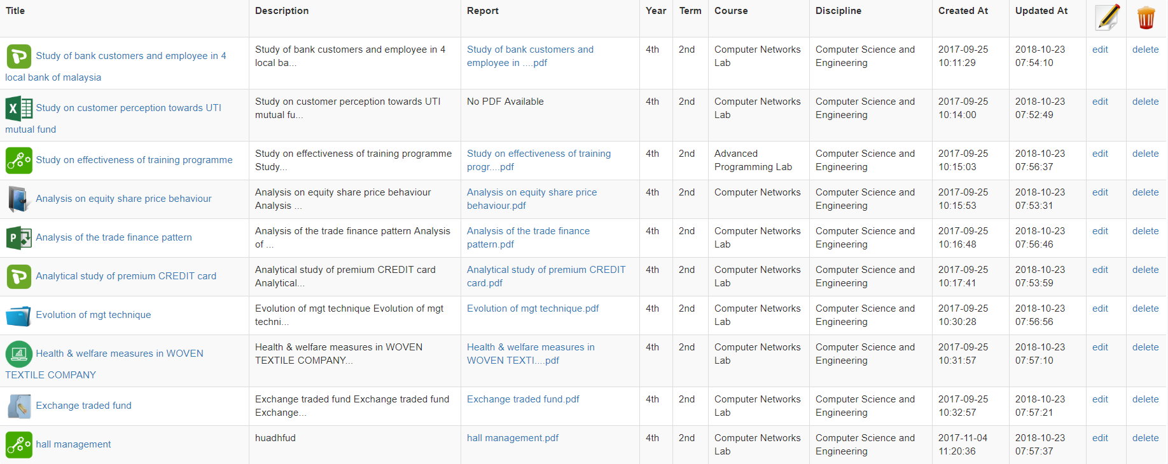

Existing Projects Showing in Manage Thesis

1. Browse Thesis  
   This page will show the user all the previous Thesis which have been done by the students. First it will give a Thumbnail look with the Thesis name and a small description. User can select from here and see the Full of the Thesis.

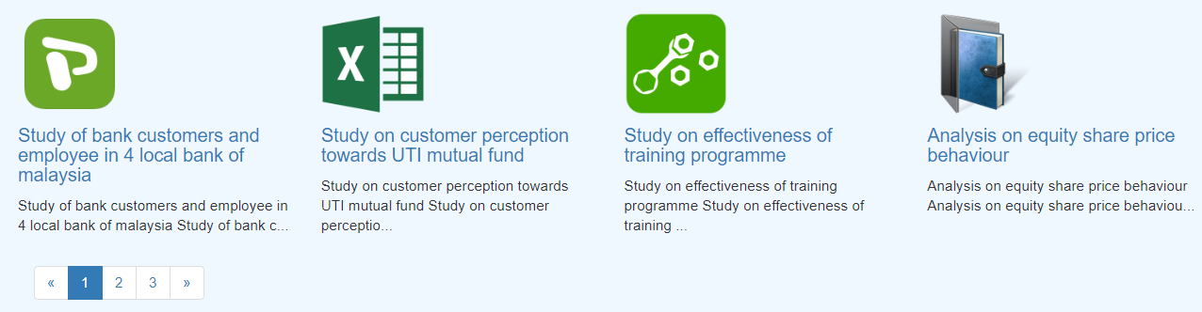

Browse Thesis

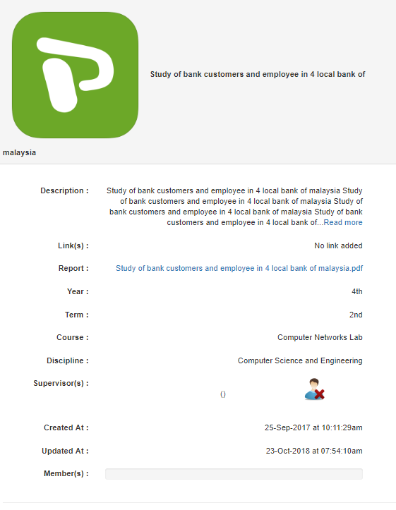

Showing one particular Thesis

1. Search Thesis   
   This page give the user the privilege to search one or more previous thesis with using some particular information like Title, Year, Term, Teacher etc. which will reduce the search result from all the previous thesis.



**Email**

This archive will have all the information about the email which is used by the user to login in this website and will also store all the details and moreover that email will also have a particular expiry date. The Admins can renew a expiry email or can extend a email’s expiry date.

There are 3 main use of this Module.  
1. Manage Emails (To Create New Email or Edit an existing one)   
2. Renew Email   
3. Expired Email

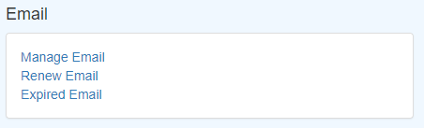

1. Manage Emails

The Page of Manage Emails has two parts. The First part is a “Create Email” Form. User can store the information of a new Email by giving the

Email, Name, Contact, Contact Email, Address, Expire At.After giving all the information the user have to click the “Create” Button.   
  
Another part of the page is consist of the data from the databse about the Thesis which are already stored here. If the user has the permission, he can also “Edit” or “Delete” an existing Proejct.

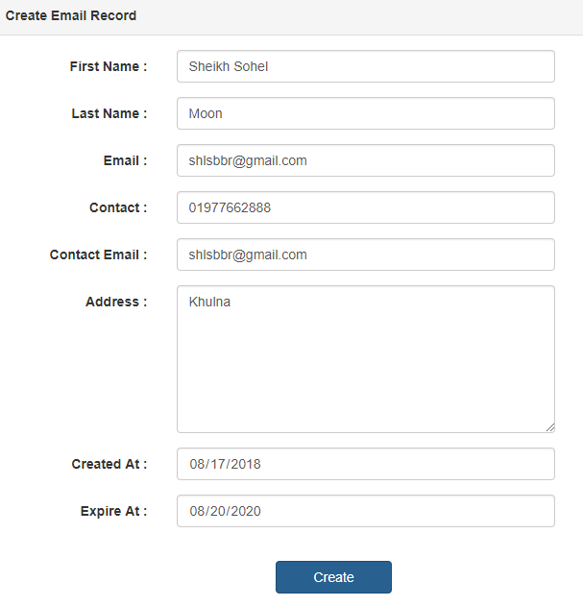

1. Renew Email  
   In this page the user will find out the emails which are renewed or in easily we can say the emails which are not Expired. With the proper permission the user can also edit email expire date.
2. Expired Email  
   In this page the user will find out about expired emails and with proper permission the user can renew a email.